**Week 8**

# 1.Querying single table 2. Filtering data 3. query multiple tables with joins

**Like operator**

|  |  |
| --- | --- |
| **LIKE Operator** | **Description** |
| where name like 'a%' | Finds any values that start with "a" |
| where name like '%a' | Finds any values that end with "a" |
| where name like '%or%' | Finds any values that have "or" in any position |
| where name like '_r%' | Finds any values that have "r" in the second position |
| where name like 'a%o' | Finds any values that start with "a" and ends with "o" |

**Joining table**

We can store our data in multiple logical tables that are linked together by a common key value.

A JOIN clause is used to combine rows from two or more tables, based on a related column between them. The join clause allows us to g**et data from two or more related tables**. We can join the tables using a **SELECT** statement and a **join condition**

**Types of Joins in MySQL**

* INNER JOIN: Returns records that have matching values in both tables
* LEFT JOIN: Returns all records from the left table, and the matched records from the right table
* RIGHT JOIN: Returns all records from the right table, and the matched records from the left table

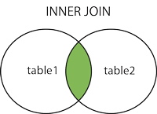 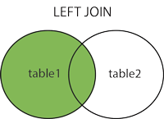 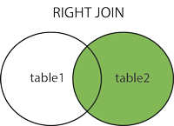

**Table : student**

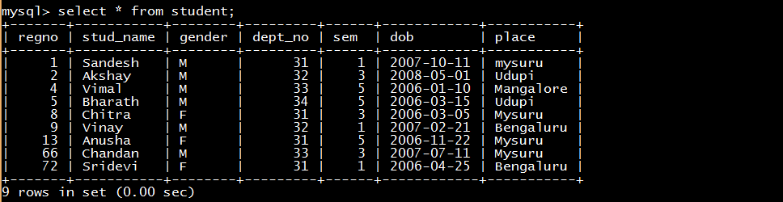

**Table : Department**



**Table : Score**

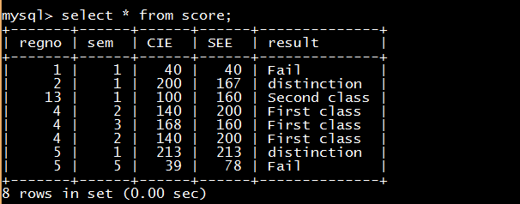

**To select student name DOB and place from student table**

**mysql>**Select Stud_name, DOB, Place from student;

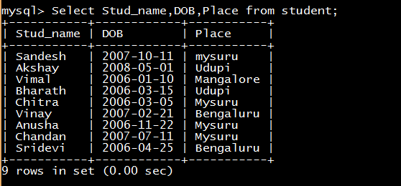

**To select students who are from Mysuru**

**mysql>**select * from Student where Place='Mysuru';

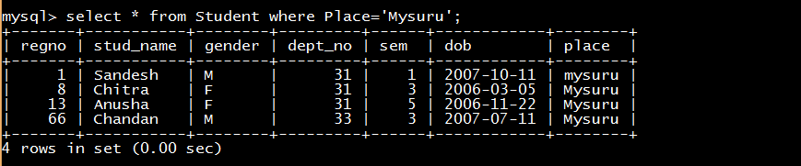

**To select students who are in 3rdsemand place is Mysuru**

**mysql>**select * from Student where Place='Mysuru' and sem=3;



**To select students who are in 3rdsem or place is Mysuru**

**mysql>**select * from student where Place='Mysuru' OR sem=3;

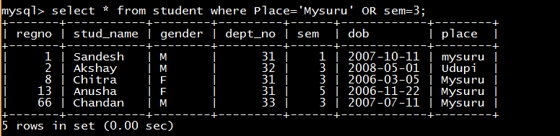

**To select students whose name end with ‘h’**

**mysql>**select * from student where Stud_name like '%h';



**To select students whose name starts with’ C’**

**mysql>**select * from student where Stud_name like 'C%';



**To select students whose name has the letter ’ t’**

**mysql>**select * from student where stud_name like '%t%';

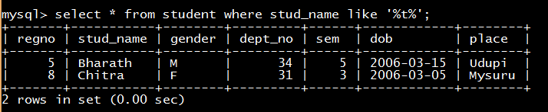

**To select students whose SEE marks is greater than or equal to 200**

**mysql>**select * from score where SEE >=200;

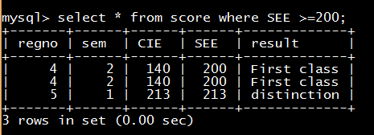

**To select students whose SEE marks is between 150 to 200**

**mysql>**select * from score where SEE between 150 and 200;

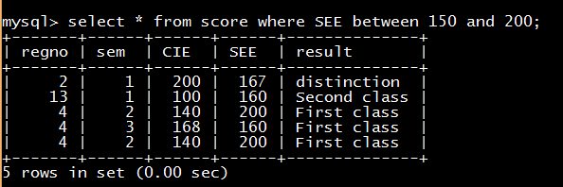

**To select student name, department number who are in department D1,D3 and D4**

**mysql>**select Stud_name,Deptno from student where Deptno in(31,33,34);

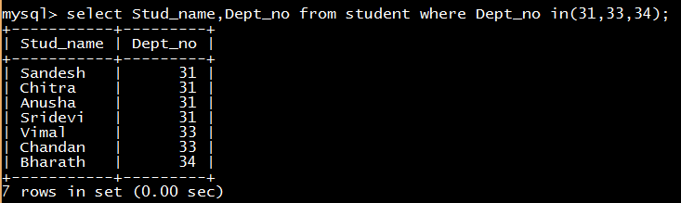

**To select student name, department number who are Not in deptno D1,D3 and D4**

**mysql>**select Stud_name, Deptno from student where Deptno NOT in(31,33,34);

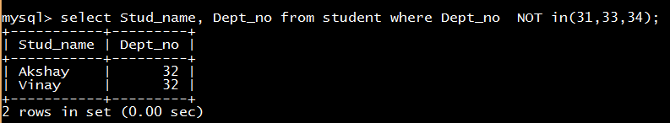

**To add 10 marks to SEE for 3rd sem students;**

**mysql>**select regno, SEE + 10 from score where sem= 3;

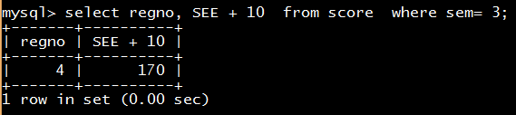

**Joining 2 tables(inner join)**

**To view student name, gender, deptname ,hod name from student,department tables**

**Mysql>**select S.Stud_name, S.gender, D.Dept_name, D.Hod from student as S inner join department as D where S.Dept_no=D.Dept_no;

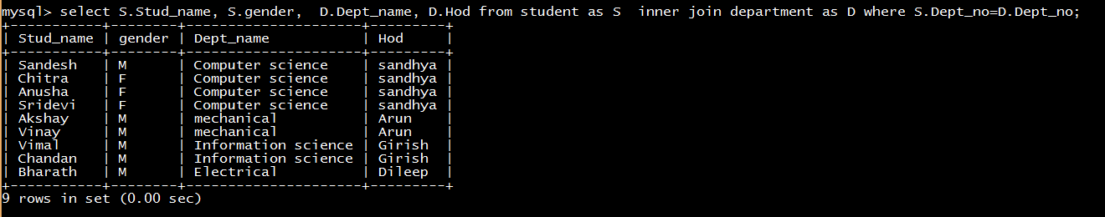

**Joining 2 tables(right outer join)**

**To view student name, sem, result from student, score tables**

**Mysql>**select S.Studentname, S.gender, SC.sem, SC.result from student as S right join Score as SC on S.regno = SC.regno;

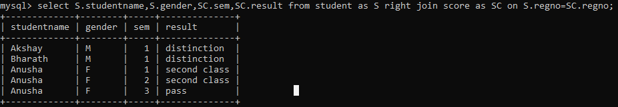

**Joining 2 tables(left outer join)**

**To view student name, sem, result from student, score tables**

**Mysql>**select S.Studentname,S.gender,SC.sem,SC.result from student as S left join Score as SC on S.regno = SC.regno;

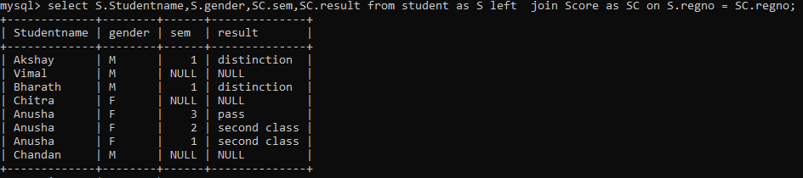

**WEEK 9**

# 1.Queries that use set operators 2. Use group functions

**Grouping data**

SQL aggregation function is used to perform the calculations on multiple rows of a single column of a table. It returns a single value. It is also used to summarize the data.

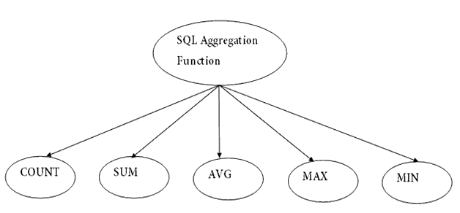

**1. COUNT FUNCTION**

Count function is used to count the number of rows in a table. It can work on both numeric and non-numeric data types.

**2. SUM Function**

Sum function is used to calculate the sum of all values in selected columns. It works on numeric fields only.

**3. AVG function**

The AVG function is used to calculate the average of all values in a column. It works on numeric fields only.

**4. MAX Function**

MAX function is used to find the largest value in a column.

**5. MIN Function**

MAX function is used to find the largest value in a column..

**To display number of students in student table**

**mysql>**SELECT Count(*) as 'No_of_students' FROM student;



**To display sum of CIE marks of all students in score table.**

**mysql>**SELECT sum(CIE) as 'total' FROM score;

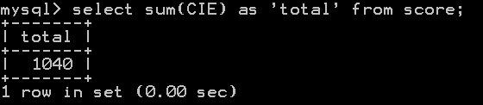

**To display average of CIE marks of all students in score table.**

mysql>SELECT avg(CIE) as 'average' FROM score;

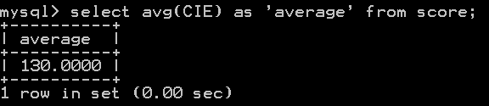

**To display maximum CIE marks in score table**

**mysql>**SELECT max(CIE) as 'maximum' FROM score;



**To display minimum CIE marks in score table**

**mysql>**SELECT min(CIE) as 'minimum' FROM score;



**GROUP BY**

GROUP BY groups the data from the table into different groups based on the criteria provided and calculates the aggregate function for each group. Thus the result has 1 row for each group. The GROUP BY statement is often used with aggregate functions (COUNT( ), MAX( ) etc) to group the result-set by one or more columns.

**To display number of students from each place**

**mysql>**select count(*), place from student group by place;

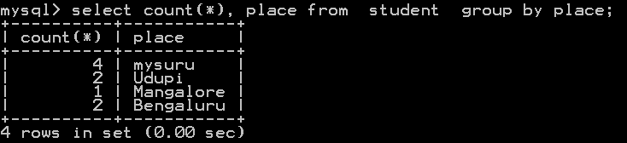

**To display number of students from each place and sort by descending order of count**

**mysql>**select count(*), place from student group by place order by count(*) desc;

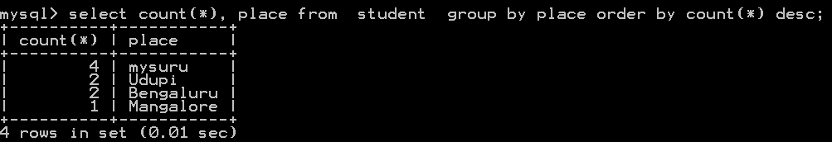

**To display number of students gender wise**

**mysql>**select count(*), gender from student group by gender

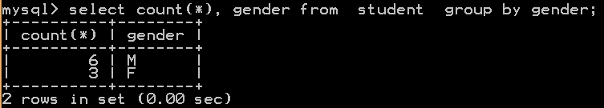

**To display number of students, semester wise**

**mysql>**select count(*), sem from student group by sem;

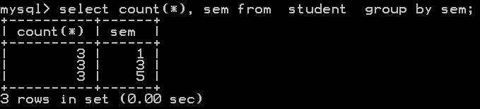

**Having Clause**

HAVING clause is used with GROUP BY clause and with aggregate functions.

**To display maximum SEE marks in each semester**

**mysql>** Select sem, max(SEE) from score group by sem;

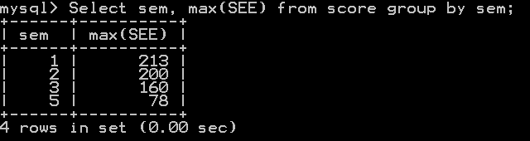

**To display maximum SEE marks in each semester if max SEE marks >200**

**mysql>**Select sem, max(SEE) from score group by sem having max(SEE) > 200;

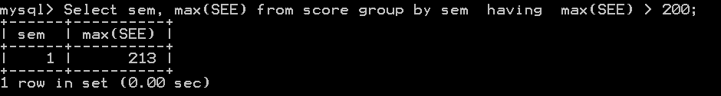

**SET Operators in SQL**

SET operators are used to combine the result of two queries.

Types of set operators:

* **UNION**
* **UNION ALL**
* **INTERSECT**
* **MINUS**

Rules to perform SET operations:

* The number and order of columns must be the same.
* Data types must be compatible.

**UNION Operation**

**UNION** is used to combine the results of two or more SELECT statements. It will not display duplicate rows.



**Table :one**  
 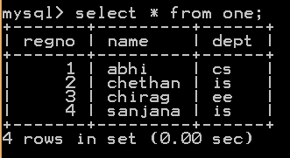

**Table : two**

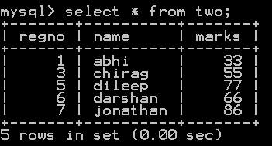

**mysql>**Select regno, name from one **union** Select regno, name from two;

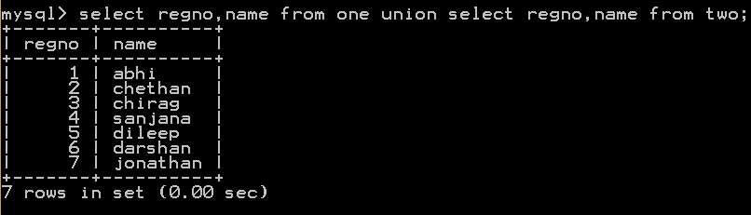

**UNION ALL**

This operation is similar to Union. But it also shows the duplicate rows.



**mysql**>Select regno, name from one  **union all** Select regno, name from two;

